Article Title (bold 15 point Times New Roman Font)
(Please Start Each Word with a Capital Letter and Continue with Lowercase)

Abstract
[The abstract should be one paragraph of between 150 and 250 words. It is not indented. Section titles, such as the word Abstract above, are not considered headings so they don’t use bold heading format. Instead, use the Section Title style. This style automatically starts your section on a new page, so you don’t have to add page breaks.]

Keywords: [Add up to 5 keywords in lowercase, but capitalize proper nouns, separate each keyword by comma]

[The body of your paper uses a half-inch first line indent. APA style provides for up to five heading levels, shown in the paragraphs that follow. Note that the word Introduction should NOT be used as an initial heading, as it’s assumed that your paper begins with an introduction.]

[Heading 1 Flush Left, Bold]
[The first three heading levels get their own paragraph, as shown here. Headings 4, and 5 are run-in headings used at the beginning of the paragraph.]

[Heading 2 Flush Left, Bold, Italic]
At vero eos et accusamus et iusto odio dignissimos ducimus qui blanditiis praesentium voluptatum deleniti atque corrupti quos dolores et quas molestias excepturi sint occaecati cupiditate non provident, similique sunt in culpa qui officia deserunt mollitia animi, id est laborum et dolorum fuga. Et harum quidem rerum facilis est et expedita distinctio. Nam libero tempore, cum soluta nobis est eligendi optio cumque nihil impedit quo minus id quod maxime placeat facere possimus, omnis voluptas assumenda est, omnis dolor repellendus. Temporibus autem quibusdam et aut officii

[Heading 3 Flush Left, Bold, Italic]
At vero eos et accusamus et iusto odio dignissimos ducimus qui blanditiis praesentium voluptatum deleniti atque corrupti quos dolores et quas molestias excepturi sint occaecati cupiditate non provident, similique sunt in culpa qui officia deserunt mollitia animi, id est laborum et dolorum fuga. Et harum quidem rerum facilis est et expedita distinctio. Nam libero tempore, cum soluta nobis est eligendi optio cumque nihil impedit quo minus id quod maxime placeat facere possimus, omnis voluptas assumenda est, omnis dolor repellendus. Temporibus autem quibusdam et aut officii

[Heading 4 Flush Left, Bold, End with a period]. At vero eos et accusamus et iusto odio dignissimos ducimus qui blanditiis praesentium voluptatum deleniti atque corrupti quos dolores et quas molestias excepturi sint occaecati cupiditate non provident, similique sunt in culpa qui officia deserunt mollitia animi, id est laborum et dolorum fuga. ita distinctio. Ceat facere possimus, omnis voluptas assumenda est, omnis dolor repellendus. Temporibus autem quibusdam et aut officii (Last Name, Year)

[Heading 5 Flush Left, Bold, Italic, End with a period]. At vero eos et accusamus et iusto odio dignissimos ducimus qui blanditiis praesentium voluptatum deleniti atque corrupti quos dolores et quas molestias excepturi sint occaecati cupiditate non provident, similique sunt in culpa qui officia deserunt mollitia animi, id est laborum et dolorum fuga. Et harum quidem rerum facilis est et expedita distinctio. Nam libero tempore, cum soluta nobis est eligendi optio cumque nihil impedit quo minus id quod maxime placeat facere possimus, omnis voluptas assumenda est, omnis dolor repellendus. Temporibus autem quibusdam et aut officii (Last Name, Year)
References
Last Name, F. M. (Year). Article title. Journal Title, 9(1), 56-68. DOI or URL (if any)
Last Name, F. M. (Year). Book title. Publisher Name. DOI or URL (if any)
Last name, F. M. (2001). Book title (3rd ed.). McGraw Hill Ryerson. DOI or URL (if any)
Last name, F. M. (2001). Chapter title (3rd ed.). In F. Last & F. Last (Eds.), The handbook of social science (5th ed., Vol. 3, pp. 333–389). Random House. DOI or URL (if any)
Last name, F. M., & Last, F. M. (2009). Article title: A case study. Online
Journal of name of the journal, 9(1), 56-68. DOI or URL (if any)

Table 1
[Table Title]

Column Head | Column Head | Column Head | Column Head | Column Head
Row Head | 111 | 222 | 333 | 444
Row Head | 111 | 222 | 333 | 444
Row Head | 111 | 222 | 333 | 444
Row Head | 111 | 222 | 333 | 444
Row Head | 111 | 222 | 333 | 444
Row Head | 111 | 222 | 333 | 444

Note: [Place all tables for your paper in a tables section, following references (and, if applicable, footnotes). Start a new page for each table, include a table number and table title for each, as shown on this page. All explanatory text appears in a table note that follows the table, such as this one. Use the Table/Figure style, available on the Home tab, in the Styles gallery, to get the spacing between table and note. Tables in APA format can use single line spacing. Include a heading for every row and column, even if the content seems obvious. A default table style has been setup for this template that fits APA guidelines.]
Figures 1
[Figures title]

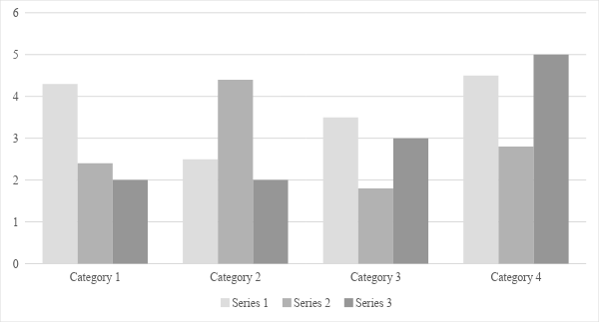

Figure 1. [Include all figures in their own section, following references (and footnotes and tables, if applicable). Include a numbered caption for each figure. Use the Table/Figure style for easy spacing between figure and caption.]

For more information about all elements of APA formatting, please consult the APA Style Manual, 7th Edition.

